What is a Block Cipher?
A block cipher is a symmetric key encryption technique that:
- Operates on fixed-size blocks of plaintext (DES uses 64-bit blocks).
- Transforms the plaintext block into a ciphertext block of the same size using a key.
- Uses the same key for encryption and decryption (symmetric key).
Confusion
Definition:
Confusion is the property of a cipher that makes the relationship between the ciphertext and the encryption key as complex as possible.
Goal:
- Even if an attacker knows some ciphertext, it should be extremely difficult to figure out the key.
How it is achieved in block ciphers:
- Substitution boxes (S-boxes): Non-linear mappings that replace input bits with output bits in a complex manner.
- Key mixing: XORing or combining data with the secret key in non-linear ways.

Effect:
- Changing a single bit in the key produces a completely different ciphertext (key avalanche effect).
Diffusion
Definition:
Diffusion is the property of a cipher that spreads the influence of a single plaintext bit over many ciphertext bits.
Goal:
- Prevent patterns in the plaintext from appearing in the ciphertext.
- Ensure that changing one bit in plaintext changes many bits in ciphertext (avalanche effect).
How it is achieved in block ciphers:
- Permutation boxes (P-boxes): Rearrange the bits of data so that each output bit depends on multiple input bits.
- Multiple rounds: Repeating substitution and permutation ensures that influence spreads across the block.
Effect:
- Prevents attackers from exploiting patterns in ciphertext.
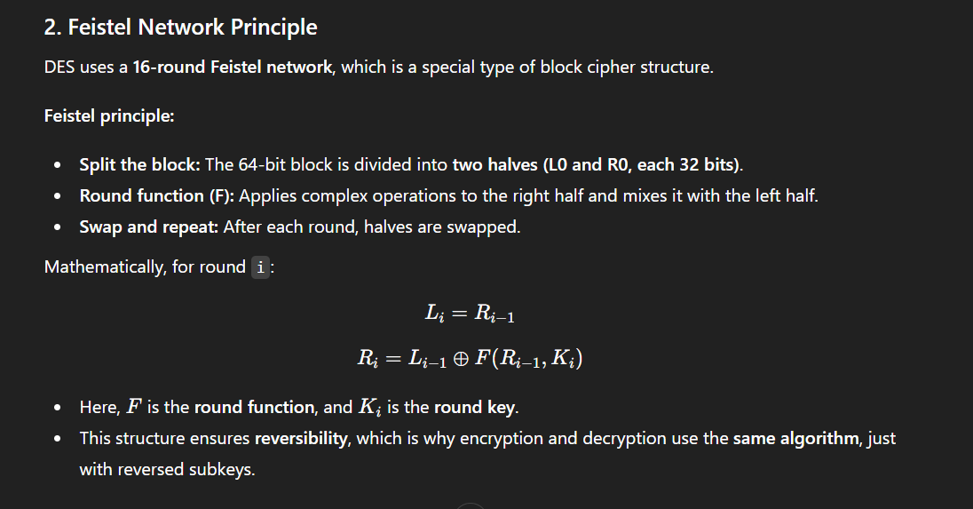
DES Encryption Steps
Step 1: Initial Permutation (IP)
- The 64-bit plaintext is first rearranged according to a fixed initial permutation table.
- This step does not provide security by itself but spreads the bits for better processing in the rounds.
Step 2: Splitting the Block
- The permuted 64-bit block is divided into two halves:
  - Left half (L0) = 32 bits
  - Right half (R0) = 32 bits

Step 3: 16 Feistel Rounds
DES uses a Feistel structure, where each round transforms the data in a reversible way.
For round i (1 ≤ i ≤ 16):
- Expansion (E-box):
  - The 32-bit right half (Ri-1) is expanded to 48 bits.
  - Expansion duplicates some bits to prepare for XOR with the 48-bit round key.
- Round Key Mixing:
  - A 48-bit subkey Ki (derived from the main key) is XORed with the expanded right half.
- Substitution (S-box):
  - The 48-bit result is divided into 8 groups of 6 bits.
  - Each group is mapped to 4 bits using a substitution box (S-box).
  - This introduces non-linearity (confusion).
- Permutation (P-box):
  - The 32-bit output from the S-boxes is permuted according to a fixed table.
  - This ensures diffusion: each output bit depends on multiple input bits.
- XOR and Swap:
  - New left half: Li = Ri-1
  - New right half: Ri = Li-1 ⊕ F(Ri-1, Ki)
This completes one round. After 16 rounds, the halves are combined in reverse order (R16L16).

Step 4: Final Permutation (FP)
- The combined 64-bit block undergoes the inverse of the initial permutation (IP⁻¹).
- This produces the 64-bit ciphertext.

4. Key Generation in DES
- 56-bit main key is used to generate 16 subkeys (one for each round).
. Decryption Process
- Follows the same structure as encryption.
- Key difference: Subkeys are applied in reverse order (K16 → K1).

